Lab – Authentication, Authorization, and Accounting

1. Objectives

Part 1: Adding Groups, Users, and Passwords on a Linux System

Part 2: Verify Users, Groups, and Passwords

Part 3: Using Symbolic Permissions

Part 4: Absolute Permissions

1. Background / Scenario

You will be conducting host security practices using the Linux command line by performing the following tasks:

* Adding Groups, Users, and Passwords
* Verifying Groups, Users, and Passwords
* Setting Symbolic Permissions
* Setting Absolute Permissions

1. Required Resources

* PC with Ubuntu installed in a VirtualBox or VMware virtual machine.

1. Adding Groups, Users, and Passwords on a Linux System

In this part, you will add users, groups, and passwords to the local host machine.

* 1. Open a terminal window in Ubuntu.
     1. Log in to Ubuntu using the following credentials:

User: **bee**

Password: **bug**

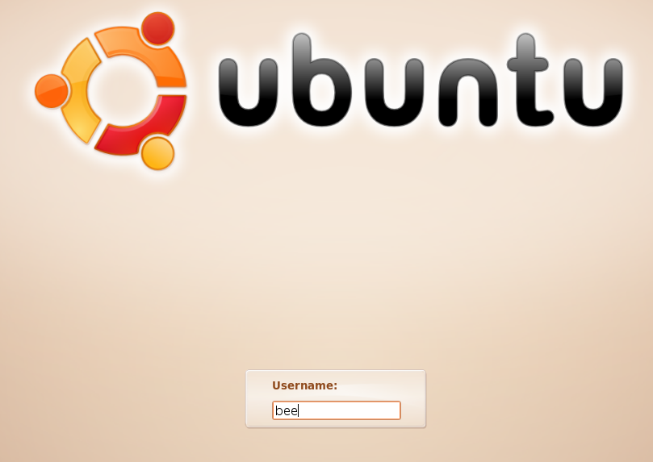

* + 1. Click on the **terminal** icon to open a terminal.

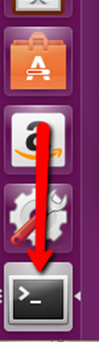

* 1. Escalate privileges to the rootlevel by entering the sudo su command. Enter the password bug when prompted.

cisco@ubuntu:~$ **sudo su**

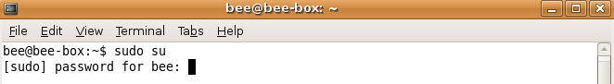

* 1. Add a new group named HR by entering the command groupadd HR.

root@ubuntu:/home/cisco# **groupadd HR**

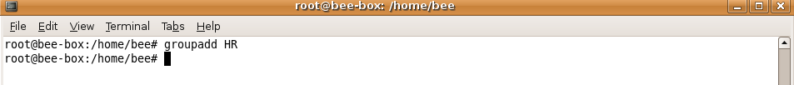

1. Verify Users, Groups, and Passwords
   1. Verify the new group has been added to the group file list by entering cat /etc/group.

root@ubuntu:/home/bee# **cat /etc/group**

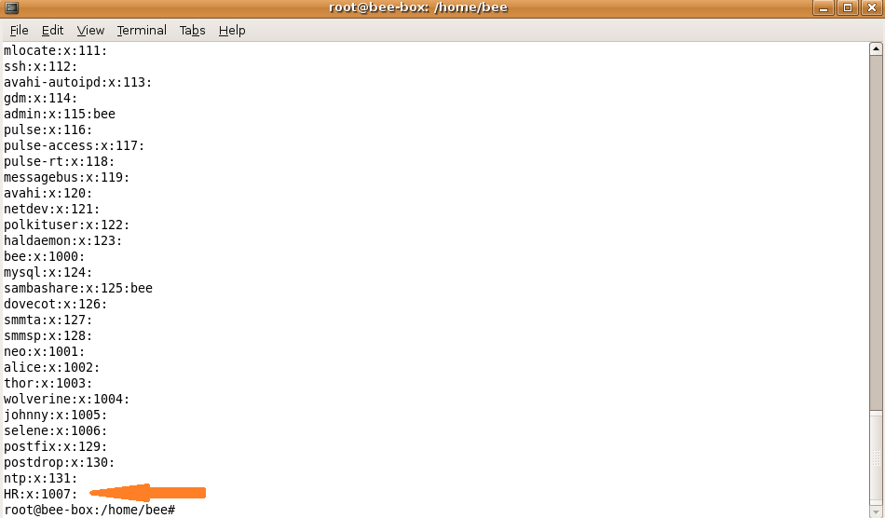

The new group HRwill be added to the bottom of the /etc/groupfile with a group IDof 1007.

* 1. Add a new user named jenny.

root@ubuntu:/home/bee# **adduser jenny**

* + 1. When prompted for a new password, type **lasocial**. Press **Enter**.
    2. When prompted again, type **lasocial**. Press **Enter**.
    3. When prompted for a full name, type **Jenny**. Press **Enter**.
    4. For the rest of the configurations, press **Enter** until when asked is the information correct.
    5. Type **Y** for yes and press **Enter**.

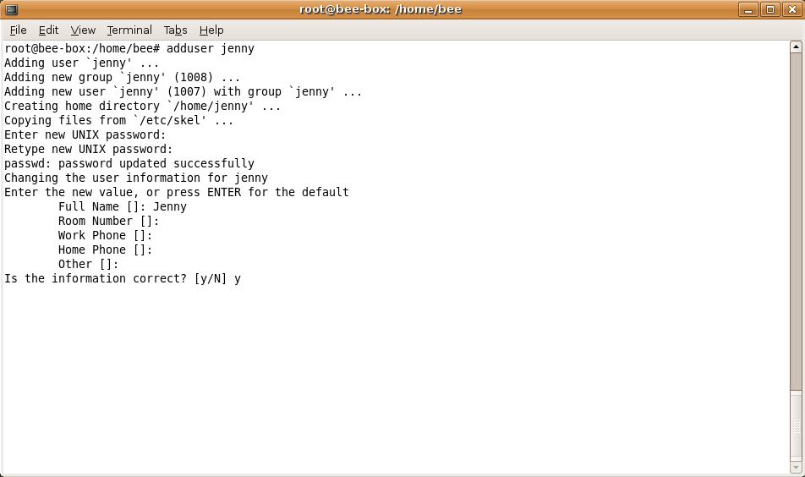

* 1. Place the user jenny in the HR group.

root@ubuntu:/home/bee# **usermod –G HR jenny**



* 1. Add another new user named joe.

root@ubuntu:/home/bee# **adduser joe**

* + 1. When prompted for a new password, type **tooth**. Press **Enter**.
    2. When prompted again, type **tooth**. Press **Enter**.
    3. When prompted for a full name, type **Joe**. Press **Enter**.
    4. For the rest of the configurations, press **Enter** until when asked is the information correct.
    5. Type **Y** for yes and press **Enter**.

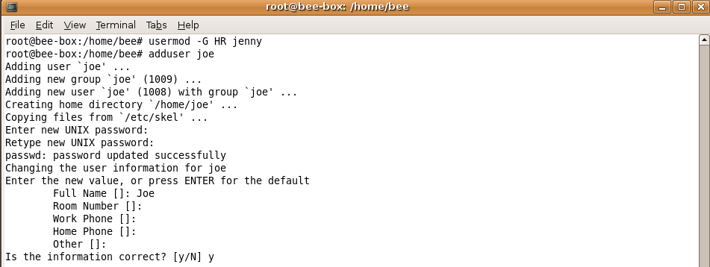

* + 1. Place the user joe in the HR group.

root@ubuntu:/home/bee# **usermod –G HR joe**



* 1. Verify the newly created users in the passwd file.

root@ubuntu:/home/bee# **cat /etc/passwd**



* 1. View the created users in the shadow file.

root@ubuntu:/home/bee# **cat /etc/shadow**

1. Using Symbolic Permissions
   1. While on the Ubuntusystem, press and hold the keys CTRL+ALT+F1 until the screen changes to the tty1 Terminal.

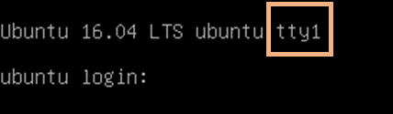

**Note**:If you are unable to use tty1 terminal, return to graphical user interface (GUI) of the host by using **CTRL+ALT+F7** and open a terminal window in the GUI Ubuntu OS. At the prompt, enter **su –l jenny** at the prompt and enter the password **lasocial**. Proceed to Step 4.

cisco@ubuntu:~$ **su –l jenny**



**Note**: If CTRL+ALT+F7 did not work, try CTRL+ALT+F8.

* 1. Once on the Terminallogin screen, type jenny and press Enter.
  2. When prompted for the password, type 123456 and press Enter.
  3. After a successful login, you will see the *jenny@ubuntu:~$* prompt.

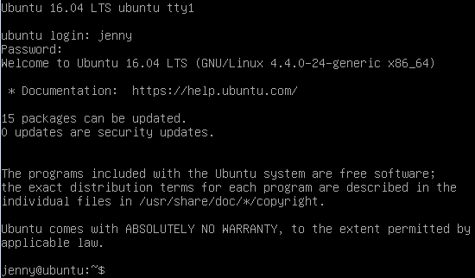

Since we are not logged in as the *root* (superuser), we are presented with the dollar sign instead of the *#* if we were to be logged in as the user root.

* 1. View your present directory.

jenny@ubuntu:~$ **pwd**



* 1. Go back one directory level to the /home directory.

jenny@ubuntu:~$ **cd ..**



* 1. List all directories and their permissions.

jenny@ubuntu:/home$ **ls -l**

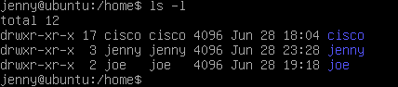

The Linux operating system has a total of 10 letters or dashes in the permissions fields:

* The first field is a dash for a file an a d for a directory
* The 2nd through 4th fields are for the user
* The 5th through 7th fields are for the group
* The 8th through 10th fields are for others (accounts other than those in the group)

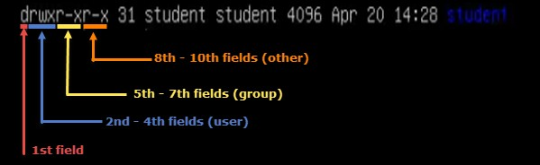

* 1. Enter Joe’s folderas Jenny by typing the command cd joe.

jenny@ubuntu:/home$ **cd joe**



Notice that we are able to go into *Joe’s home folder*.

jenny@ubuntu:/home/joe$ **cd ..**



* 1. Press and hold CTRL+ALT+F2 to switch to another Terminalsession (tty2).

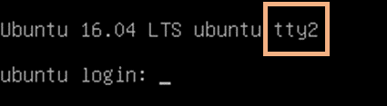

* 1. Login as the user root with the password bug.

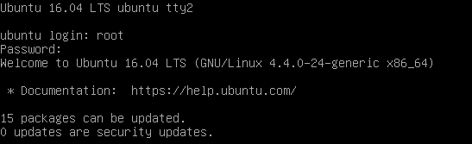

**Note**:If you are unable to use tty2 terminal, return to graphical user interface (GUI) of the host by using **CTRL+ALT+F7** and open a terminal window in the GUI Ubuntu OS. At the prompt, enter **sudo -i** at the prompt and enter the password **bug**.



* 1. Change to the /home directory.

root@ubuntu:~# **cd /home**



* 1. Change the “other” permission on joe’s folder by making it non-executable.

root@ubuntu:/home# **chmod o-x joe**



* 1. List the directories once more with their respective permissions.

root@ubuntu:/home# **ls -l**

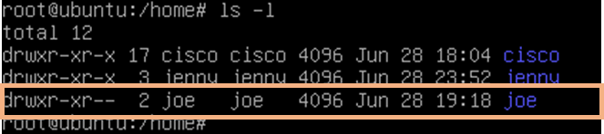

Notice now that there are two dashes in the “others” field for joe’s folder.

* 1. Press and hold CTRL+ALT+F1 to switch back to the other Terminal session (tty1). Make sure you are viewing the following command prompt: jenny@ubuntu:/home$.
  2. Attempt to go into Joe’s folder once more.

jenny@ubuntu:/home$ **cd joe**



Notice that we do not have the permissions to do so.

The chart below shows examples of other ways the **chmod** command can be used:

|  |  |
| --- | --- |
| chmod command | Results |
| chmod u+rwx | Adds read, write, and execute permissions for the user |
| chmod u+rw | Adds read and write permission for the user |
| chmod o+r | Adds read permission for others |
| chmod g-rwx | Removes read, write, and execute permissions for the group |

* 1. Type exit followed by pressing Enter to logout of the Terminal session.

1. Absolute Permissions
   1. Login as the user joe with the password tooth while on tty1.

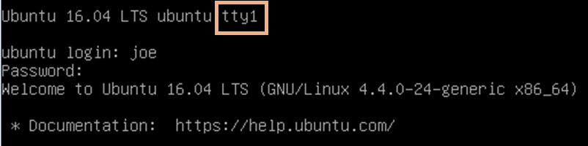

**Note:** If you are unable to use tty1 terminal, return to graphical user interface (GUI) of the host by using **CTRL+ALT+F7** and open a terminal window in the GUI Ubuntu OS. At the prompt, enter **sudo –l joe** at the prompt and enter the password **tooth**.

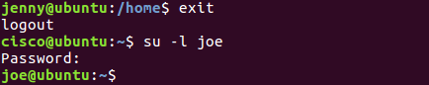

* 1. Print your current working directory.

joe@ubuntu:~$ **pwd**



* 1. Go back one directory level to the /homedirectory.

joe@ubuntu:~$ **cd ..**



* 1. List all directories and their permissions in the current working directory.

joe@ubuntu:/home~$ **ls -l**

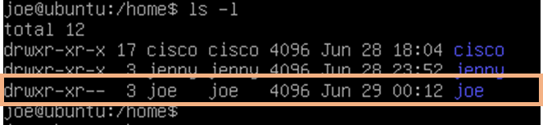

Notice that Joe’s folder is set so that “others” are not able to access the folder.

The other way of assigning permissions besides using symbolic permissions is the use of absolute permissions. Absolute permissions use a three digit octal number to represent the permissions for owner, group and other.

The table below outlines each absolute value and its corresponding permissions:

|  |  |
| --- | --- |
| Number | Permissions |
| 7 | Read, Write, and Execute |
| 6 | Read and Write |
| 5 | Read and Execute |
| 4 | Read |
| 3 | Write and Execute |
| 2 | Write |
| 1 | Execute |
| 0 | None |

By typing the command **chmod 764 *examplefile***, the examplefile will be assigned the follow permissions:

* The user will get read, write and execute permissions
* The group will get read and write permissions
* Others will get read access

Breakdown of how 764 represents these permissions:

|  |  |  |
| --- | --- | --- |
| Digit | Binary Equivalent | Permission |
| 7 (user) | 111 | 1-Read 1-Write  1-Execute |
| 6 (group) | 110 | 1-Read 1-Write  0-No Execute |
| 4 (others) | 100 | 1-Read  0-No Write  0-No Execute |

* 1. Modify the “others” field for Joe’s folder so that others will be able read and execute but not write while still maintaining the “user” field to read, write, and execute.

joe@ubuntu:/home$ **chmod 705 joe**



* 1. List the file permissions of the current directory to see that the absolute changes were made.

joe@ubuntu:/home$ **ls -l**

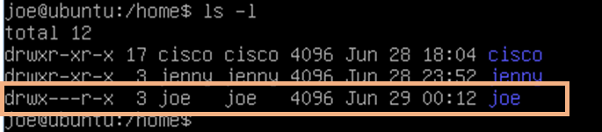

* 1. Change to the */home/joe* directory.

joe@ubuntu:/home$ **cd joe**



* 1. Create a simple text file named test.txt using *touch*.

joe@ubuntu:~$ **touch test.txt**



* + 1. Type **exit** followed by pressing **Enter** to log out of Joe’s session.
    2. While on the tty1 Terminal, log back in as **jenny** and enter the password **lasocial**. Press **Enter**.

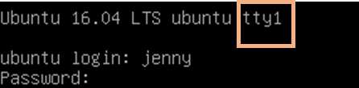

**Note**:If you are unable to use tty1 terminal, return to graphical user interface (GUI) of the host by using **CTRL+ALT+F7** and open a terminal window in the GUI Ubuntu OS. At the prompt, enter **su –l jenny** at the prompt and enter the password **lasocial**.

cisco@ubuntu:~$ **su –l jenny**

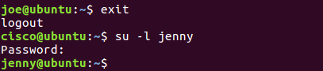

* 1. Change to the /home directory.

jenny@ubuntu:~$ **cd /home**



* 1. List all directories with their respective permissions.

jenny@ubuntu:/home$ **ls -l**

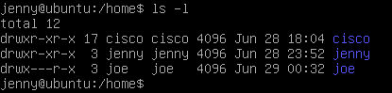

* 1. Change to the /home/joe directory and list the content of the directory.

jenny@ubuntu:/home$ **cd joe**

jenny@ubuntu:/home/joe$ **ls -l**

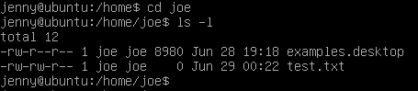

Notice that we are able to enter Joe’s folder and read the files within the directory. We are able to see the *test.txt* file.

* 1. Attempt to create a file.

jenny@ubuntu:/home/joe$ **touch jenny.txt**



Notice we do not have permission to create the file.

* 1. Close all remaining windows.